69 Sycamore Lane  Lower Sackville, NS B4C 1E9  Phone: 902.864.6730  Email: sles@hrce.ca | 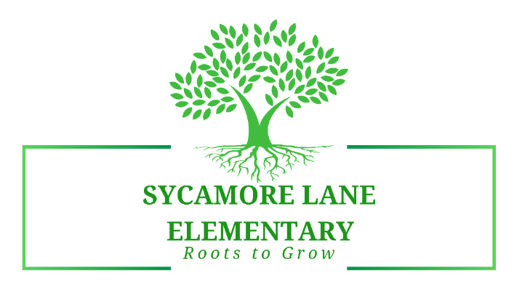
Janice Graham, Principal ◊ Mary Middleton, Vice Principal ◊ Sonja Moore, Administrative Assistant
SAC Meeting Minutes
6:00 p.m. Monday, February 7, 2022
______________________________________________________________________

Attendance:
Kathy Tucker, Val Collins, Mary Middleton, Janice Graham

Principal’s Report:
- COVID procedures in school are still operating well:
  - Student mask wearing is going well
  - Maintaining social distance as much as possible
  - Hand sanitizing where possible – when classes enter and exit classrooms from outside and within the building, they hand sanitize; hand sanitizer is in each classroom
  - Classes currently remain with their own cohort class
  - Specialist teachers go to classrooms (for Music and French); students attend Physical Education class in the gymnasium
- Finances – reviewed that SAC supported the school request to offset costs from Instructional Budget. The funds requested were $4,520.24. This was approved and has been taken off of the SAC funds.
- We have received our allocation of funds for the 2021 – 2022 school year. This amount is $4229.00
- The balance of funds in our SAC account as of February 7, 2022, is $6,427.87.
- The financial sheet, as of February 7, 2022, has been printed out and attached to the minutes. This ledger will account for the funds that were spent and the funds we have remaining this school year.
- Membership – discussion around membership and what we can do to try and get more diversity for our SAC. Currently, we do not have enough members for Community and Parent Groups, so we are looking to have more members join our team. Val indicated she would check with some individuals to see if they are interested in serving on the SAC. We look forward to hearing back from her.

Next SAC Meeting: Monday, February 28, 2022 at 5:00 p.m. (via Zoom)

Meeting Adjourned.

Minutes Respectfully Submitted,

Janice A.M. Graham
Janice Graham

