69 Sycamore Lane  Lower Sackville, NS B4C 1E9  Phone: 902.864.6730  Email: sles@hrce.ca | 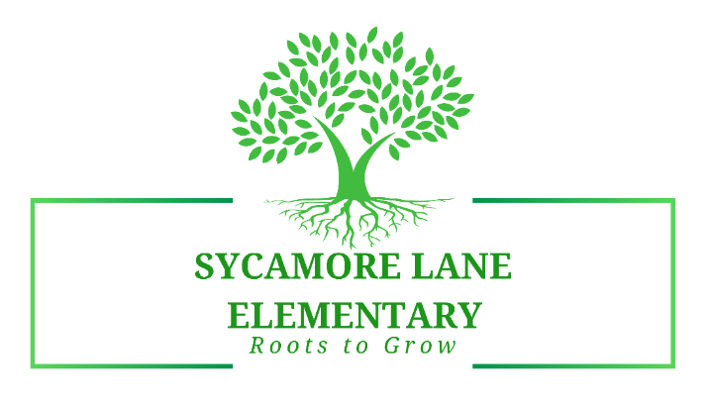
Janice Graham, Principal ◊ Mary Middleton, Vice Principal ◊ Sonja Moore, Administrative Assistant
Sycamore Lane Elementary
School Advisory Council
Meeting Minutes
October 16, 2023
_________________________________________________________________
Attendance: Sean Kelly, Liann Dearman, Val Collins (via Zoom), Mirza Hussain, Darrell Bailey, Mary Middleton, Janice Graham
Regrets: Julie Boudreau, Lydia Ritcey, Caitlyn Lovett
Agenda Items: Review of items from last meeting; was a small gathering and no decisions were made.
- SAC Finances – it was noted that we should be receiving the $5,000 grant money from HRCE that we can use to purchase resources or provide funding for other school related activities.
- SAC Bylaws – Copies of these were provided to all members for information sharing around the operating procedures of an SAC Group.
It was agreed by all present at the meeting that the Letter of Agreement for the length of term for each member would be 2 years, to establish some consistency with this committee.
Val Collins has agreed to be the SAC Chair for this year and will attend any professional development sessions for SAC members.
- SAC Letter of Agreement – copies provided at meeting for information of membership.

- Principal’s Report:

Principal’s report included information on:
- Enrollment numbers and that our numbers had increased, which resulted in class configuration being required. As we worked through this transition, students seem to be settling into their classrooms nicely.
- Our lunch program is still lacking in a few monitors, so we could use some help with having available people to come in and fill in for absences. We have had a few additions (namely Barb and we had another lunch monitor newly join us). So, things are improving, but we always can use more names of those who may be interested.
- Recess and Lunch Play items – Darrell brought in some new basketballs and skipping ropes, as well as two large hockey nets that have been donated to our school. These have gone into our rotations of equipment for outside play times. The basketballs and skipping ropes are being managed by our Schools Plus CYCP worker. She takes the bag out each day and students can borrow this equipment. She then ensures that they return the equipment so that we can ensure we have access to it for as long as possible. The children were so excited to see the new nets and they use these on a frequent basis when playing soccer.
- Student Success Planning – staff have been continuing to work on our school goals:
  - Literacy in the area of reading with focus on phonological awareness (UFLI lessons daily in P – 3 classrooms)
  - Mathematics in the area of Computational Fluency
  - Student Well-being in the area of feeling accepted and a sense of belonging in classrooms.
- School data for Literacy and Mathematics will be available at our next SAC meeting (and some of this information will be included in upcoming newsletters). We have 1st term report cards coming up and will be conducting our formal summative assessments in reading and mathematics. The school principal will then compile this data to present at our first meeting in January and set the stage for our next steps moving forward in our Student Success Plan.

- School Communication:
  - As a point of sharing, Janice informed all SAC members that we will continue to use our school automated message system as our main means of information sharing. We also have a bi-monthly newsletter that is shared with families, and our school website has information on policies and contact information. If anyone on SAC has information, they would like to have shared in our school community, please email to Janice at jgraham@hrce.ca.

- Finances for SAC this year:
  - The SAC team discussed finances and ways in which this money can be utilized throughout the year.
  - Janice discussed the UFLI program with our SAC and informed them of the literacy-based program and the focus on phonetic awareness skills, which is an area of focus for all teachers for our students. These lessons are done daily, and it is vital in student language development and literacy skills. This is foundational in that these lessons work on letter/sound relationships; how to blend sounds; how to make words. This work then transfers to reading these sounds; blends and words; and then further transfers to writing skill development.
  - It was asked of the SAC if they would be willing to support the funding for this program. Sean Kelly motioned that this was an acceptable purchase, which was seconded by Darrell Bailey. The approximate cost for purchasing materials (magnetic letters for all students (125 students) and cookie sheets to manipulate the letters to “make words”, was $1500.00. This will be funded by the SAC.

Next Meeting:
Monday, November 20, 2023
6:00 p.m. in School Library

